**I. Topic and expected final product of the project**

**1. Topic**

* Research , learn and demo how to use BusyBox

**2. Expected final product:**

* A webserver - building by httpd utility of BusyBox and cgi-script that :

- Provide an interface that showing the list of files and folders that serve by the httpd server

- Allow client download file and folder that server by the server

- Support basic authentication (username and password) , allow the owner to :

+ Upload file

+ Create folder

+ Rename file

+ Edit the text file

+ Delete files/folders

+ Copy files/folders to a directory

- Deny, allow access from specific IP addresses.

* Deploy and test webserver on a Linux-based System (built by QEMU and Busybox)

**II. Introduction to Busybox , QEMU and httpd**

**1. BusyBox - The Swiss Army Knife of Embedded Linux**

Pic 1: Logo of BusyBox

**1.1. What is BusyBox**

- BusyBox is a software package that provides a collection of common UNIX utilities in a single executable file

- It is designed to be lightweight and efficient, making it well-suited for embedded systems and resource-constrained environments

**1.2 Why we need BusyBox:**

-In a regular Linux distribution, each command (such as ls,ps,…) corresponds to a separate program. Busybox combines all of these commands into a single program, residing in a single file named "busybox"​.

=>The commands cp, ls, cat, etc. are symbolic links to this single Busybox file

- Also BusyBox remove some rarely used or unnecessary command

=> **BusyBox help saving storage space in embedded systems which are typically limited in terms of storage capacity and memory.**



Pic 2 : Size of /bin in Ubuntu – about 200 MB Pic 3: Size of /bin (busybox) : 2.6 M

**2 . httpd and cgi-script**

**2.1. httpd**

- httpd (HTTP Daemon) is an utility of BusyBox .Function of httpd is listen for incoming HTTP

- httpd help us to build a lightweight HTTP webserver

- Enables us to interact with the embedded system through a web browser to perform administrative tasks, update settings

**2.2 cgi-script**

-CGI (Common Gateway Interface) script is an interface specification that enables web servers to execute an external program, typically to process user requests

Pic 4 :How httpd server work with cgi-script

(Source: <https://www.loginsoft.com/>)

-Why we need CGI (bash) script? ​

+HTML only can show the static content​

+We want to build a web server to serve file and let client do some action on the file​

=> List of file must be generate dynamically,not statically ​

- Busybox httpd can execute CGI scripts ,allow us to run dynamic web application , ​even perform some action on file/folder

**3. QEMU**



Pic 5 : Logo of QEMU

-QEMU (Quick Emulator) is an open-source virtualization software that allows us to emulate and run operating systems and software on various hardware platforms

-It provides a framework for full system emulation, enabling us to create virtual machines and run different operating systems within them.

**III. Project Implementation:**

**1. Build a minimal Linux from scratch using QEMU and Busybox:**

* To build a minimal Linux from scratch need 2 key artifact : Kernel Image and Disk Image

**- (Build) Kernel Image:**

+Download from source :

wget <https://mirrors.edge.kernel.org/pub/linux/kernel/v5.x/linux-5.15.6.tar.xz>

+Decompress : **tar -xf linux-5.15.6.tar.xz**

+Create default kernel configuration file : **make defconfig**

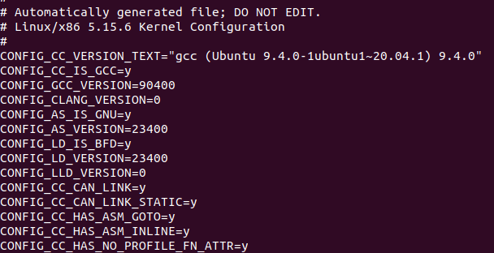

Pic 6: Some first row of .config file

Compile the kernel : make

Finally , we can have a kernel image : **bzImage** file in arch/x86/boot

Pic 7: Location of bzImage after compile kernel successfully

**- Disk Image (init root device)**

**(+ Includes all program to be run**

**+ Used by kernel as root of Virtual File System)**

+ Download busybox from source

wget <https://busybox.net/downloads/busybox-1.34.1.tar.bz2>

+ Decompress : **tar -xf busybox-1.34.1.tar.bz2**

+ Create configuration file :**make menuconfig** ,choose build static binary

Pic 8: Menu config of busybox

+ Compile busybox : make

+ After compile ,we will get the single executable binary file busybox



Pic 9: Size of busybox

+ Create initrd folder and its subfolder : bin proc sys dev home

+ Create symbolic link for various command to busybox in bin

Pic 10-11: symbolic link to /bin/busbox

+Create CPIO archive with newc format (commonly used for Linux initial RAM disks) : **find . | cpio -o -H newc > ../initrd.img**

**-Create init file :**

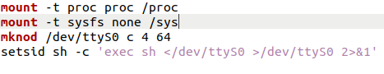

Mount proc filesystem (interface to kernel data structures and system information) to /proc directory: **mount -t proc proc /proc**

Mount sysfs filesystem (system's device hierarchy) to the /sys directory :

**mount -t sysfs none /sys**

Creates a character device node : **mknod /dev/ttyS0 c 4 64**

Start a new shell session : **setsid sh -c 'exec sh </dev/ttyS0 >/dev/ttyS0 2>&1'**

**- Build minimal Linux :**

**sudo qemu-system-x86_64 -kernel bzImage -initrd initrd.img -nographic**

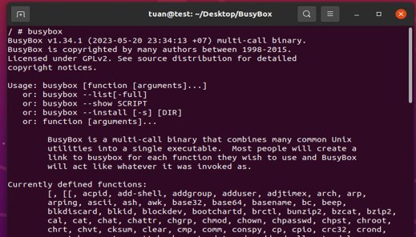

Pic 12: Result of building Linux

**2 .Build webserver**

**2.1 .Show the list of the file dynamically: (list_files.sh)**

Pic 13: Content of list_files.sh

Idea :

- Using for loop to get all the file and folder of current location :

**for file in "$path"/*; do**

- Using some command get information of each file/folder:

+ **du -sh** : Get the file/folder size

+ **stat -c %U** : Get owner of the file/folder

+ **stat -u %y** : Get the latest date modify of the file

-If we click the folder , it will show all the file/folder of that directory by call the list_files.sh again with new query path:

**if [ -d "$file" ]; then**

**echo "<td><a href=\"list_files.sh?path=/$relativePath\">$filename</a></td>"**

**2.2 Download file/folder**

Idea

-For file : Using download attribute of html <a> tag

**<a href=\"$relativeLink\" download>Download</a>**

-For folder :**Write download.sh**

Pic 14: Step of download folders

+ Compress the folder first : tar -czf "download.tar.gz" "$folder_path"

+ Send the content to client : cat "download.tar.gz"

+ Finally Remove the temporary file download.tar.gz



Pic 15: Content-type for downloading

+ The content-type must be application/octet-stream to indicate that this is a arbitrary binary file and send to client as an attachment using “Content-Disposition”

**2.3 Upload file :**

Idea : Using html form



Pic 16: html form for uploading

Client upload the file through <input type=file> and then submit to server using “post” method.

Server will read the content of the uploaded file then write it to a new file:

Pic 17: How to get file name

To get the filename of the uploaded file ,we can read each line of the content and find the “filename” and get the value

**2.4 Edit file :**

Pic 18: Text area to edit file

-First copy the current file content to a text area

-Then using html form to submit the new content and trigger the action handlesave.sh

Pic 19: Handlesave script

handlesave.sh will read the content will parse the content of textarea (using **httpd -d** command) and overwrite to the file using :echo **"$CONTENT" > "$FILE_PATH"**

**2.5 Other action: Simply use basic command :**

-Rename a file/folder (rename.sh): **mv $folder_path $new_path**

-Delete file/folder (remove.sh): **rm -rf $folder_path**

-Copy (copy.sh) : **cp -r "$src" "$des"**

-Create folder : **mkdir -p**

-Delete multiple file/folder : Using checkbox (<input type="checkbox">) ,then using for loop to delete the chosen file/folder:

Pic 20: Function inside <script> tag

-The action rename,delete,create folder are written as function in <script> tag they will call to the corresponding cgi-script by using fetch() . Finally reload the page **location.reload()** to show the new change

**2.6 Simple authentication and Deny IP Address Access**

**Define in httpd.conf**

Pic 21: Template of file httpd.conf

**\* Syntax for authentication : path:<username>:<password>**

Eg : /cgi-bin/delete.sh:admin:123456

**\* Syntax for deny IP access: D: <IP address>**

Eg: D:10.0.2.16

**3.Deployment:**

**3.1 Set up bridge network**

-Creates a new bridge interface br0.

**sudo ip link add br0 type bridge**

- Adds a new TAP (network tap) interface tap0

**sudo ip tuntap add dev tap0 mode tap**

-Adds the enp0s3 interface to the bridge interface br0, making it a member of the bridge

**sudo ip link set dev enp0s3 master br0**

-Adds the tap0 interface to the bridge interface br0, making it another member of the bridge

**sudo ip link set dev tap0 master br0**

-Brings up the bridge interface br0, activating it and enabling traffic flow through it**.**

**sudo ip link set br0 up**

- Removes the IP address 10.0.2.15 from the enp0s3 interface

**sudo ip address delete 10.0.2.15 dev enp0s3**

-Assigns the IP address 10.0.2.15 with a subnet mask of /24 to the bridge interface br0.

**sudo ip address add 10.0.2.15 /24 dev br0**

-Adds a default route to the IP routing table, directing all traffic to the default gateway with the IP address 10.0.2.2, through the bridge interface br0

**sudo ip route add default via 10.0.2.2 dev br0**

Pic 22: Network interface after add

**3.2 Append the init file for starting webserver :**

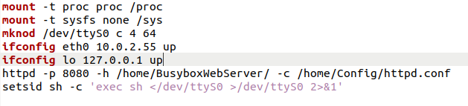

Pic 23: New content of init file

-Assigns the IP address 10.0.2.55 to the eth0 interface and bring it up :

**ifconfig eth0 10.0.2.55 up**

-Assigns loopback IP address 127.0.0.1 to the lo (loopback) interface andbring it up :

**ifconfig lo 127.0.0.1 up**

-Start the webserver at port 8080 host all file in BusyBoxWebServer with the configuration define at /home/Config/httpd.conf

**httpd -p 8080 -h /home/BusyBoxWebServer/ -c /home/Config/httpd.conf**

**3.3 Rebuild the Linux-kernel based VM:**

**sudo qemu-system-x86_64 -kernel bzImage -initrd initrd.img -nographic -net nic -net tap,ifname=tap0**

**-net nic:** creates a virtual network card that can be connected to a network.

**-net tap,ifname=tap0 :**connects the virtual NIC to tap0

**IV. Result and Test**

* Open FireFox, enter 10.0.2.55:8080/cgi-bin/list_files.sh?path=/.We can see the result below

Pic 23: Webserver interface

* Test Authentication: Enter button delete ,there will be a prompt

Pic 24: Authentication prompt

-That means authentication works and we have to fill correctly to perform that action

**\* Test Deny IP Address Access:**

-Change the IP to 10.0.2.16:

+ sudo ip address delete 10.0.2.15 dev br0

+ sudo ip address add 10.0.2.16/24 dev br0

- Result :

The page show 403 Forbidden ,it mean the deny IP address function work well

**V. Task Assignment**

|  |  |  |
| --- | --- | --- |
| Name | StudentId | Task |
| Nguyễn Minh Tuấn | 20194876 | -Compile kernel (bzImage) and busybox  -Write script to  + Download file/folder  + Modify text file  + Upload file  + Delete file/folder ,multiple file/folder |
| Nguyễn Thụ Hiếu | 20194761 | -Write init file to mount file system ,networking and start httpd server  -Write script to  + List file  + Search file  + Rename file  + Create Folder |
| Lê Đức Huy | 20194777 | - Set up bridge network and test authentication , IP access/deny  - Write  + Script to copy file ,select folder to copy  + httpd.conf file to support authentication |